# CS 255 System Design Document Template

## UML Diagrams

### UML Use Case Diagram

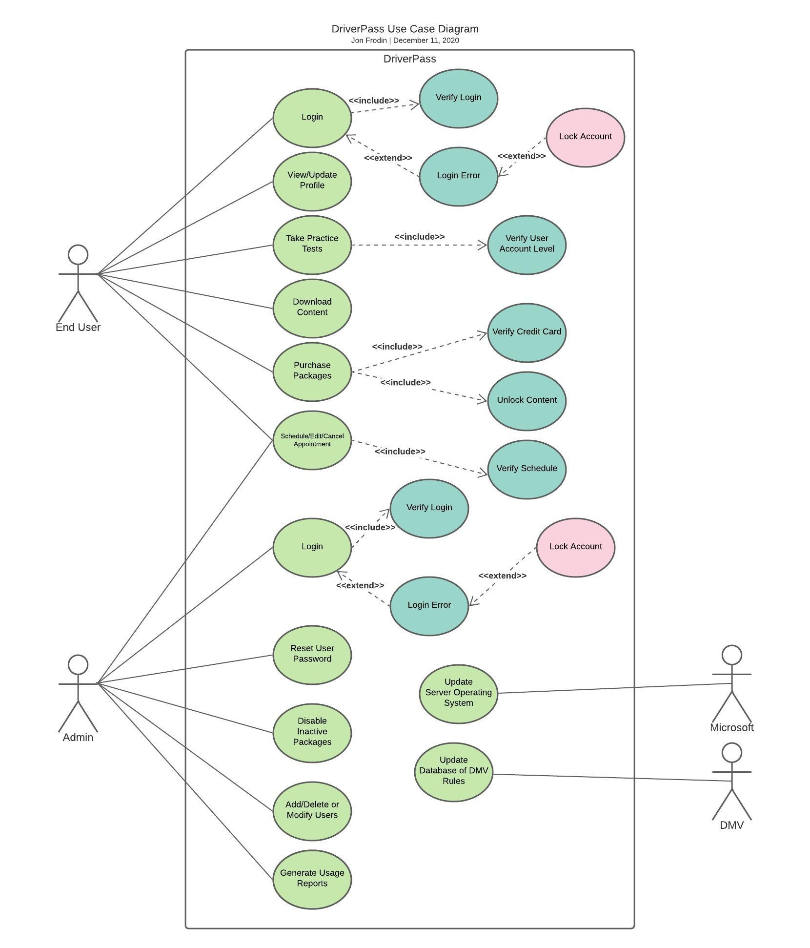

### UML Activity Diagrams

### 

### UML Sequence Diagram

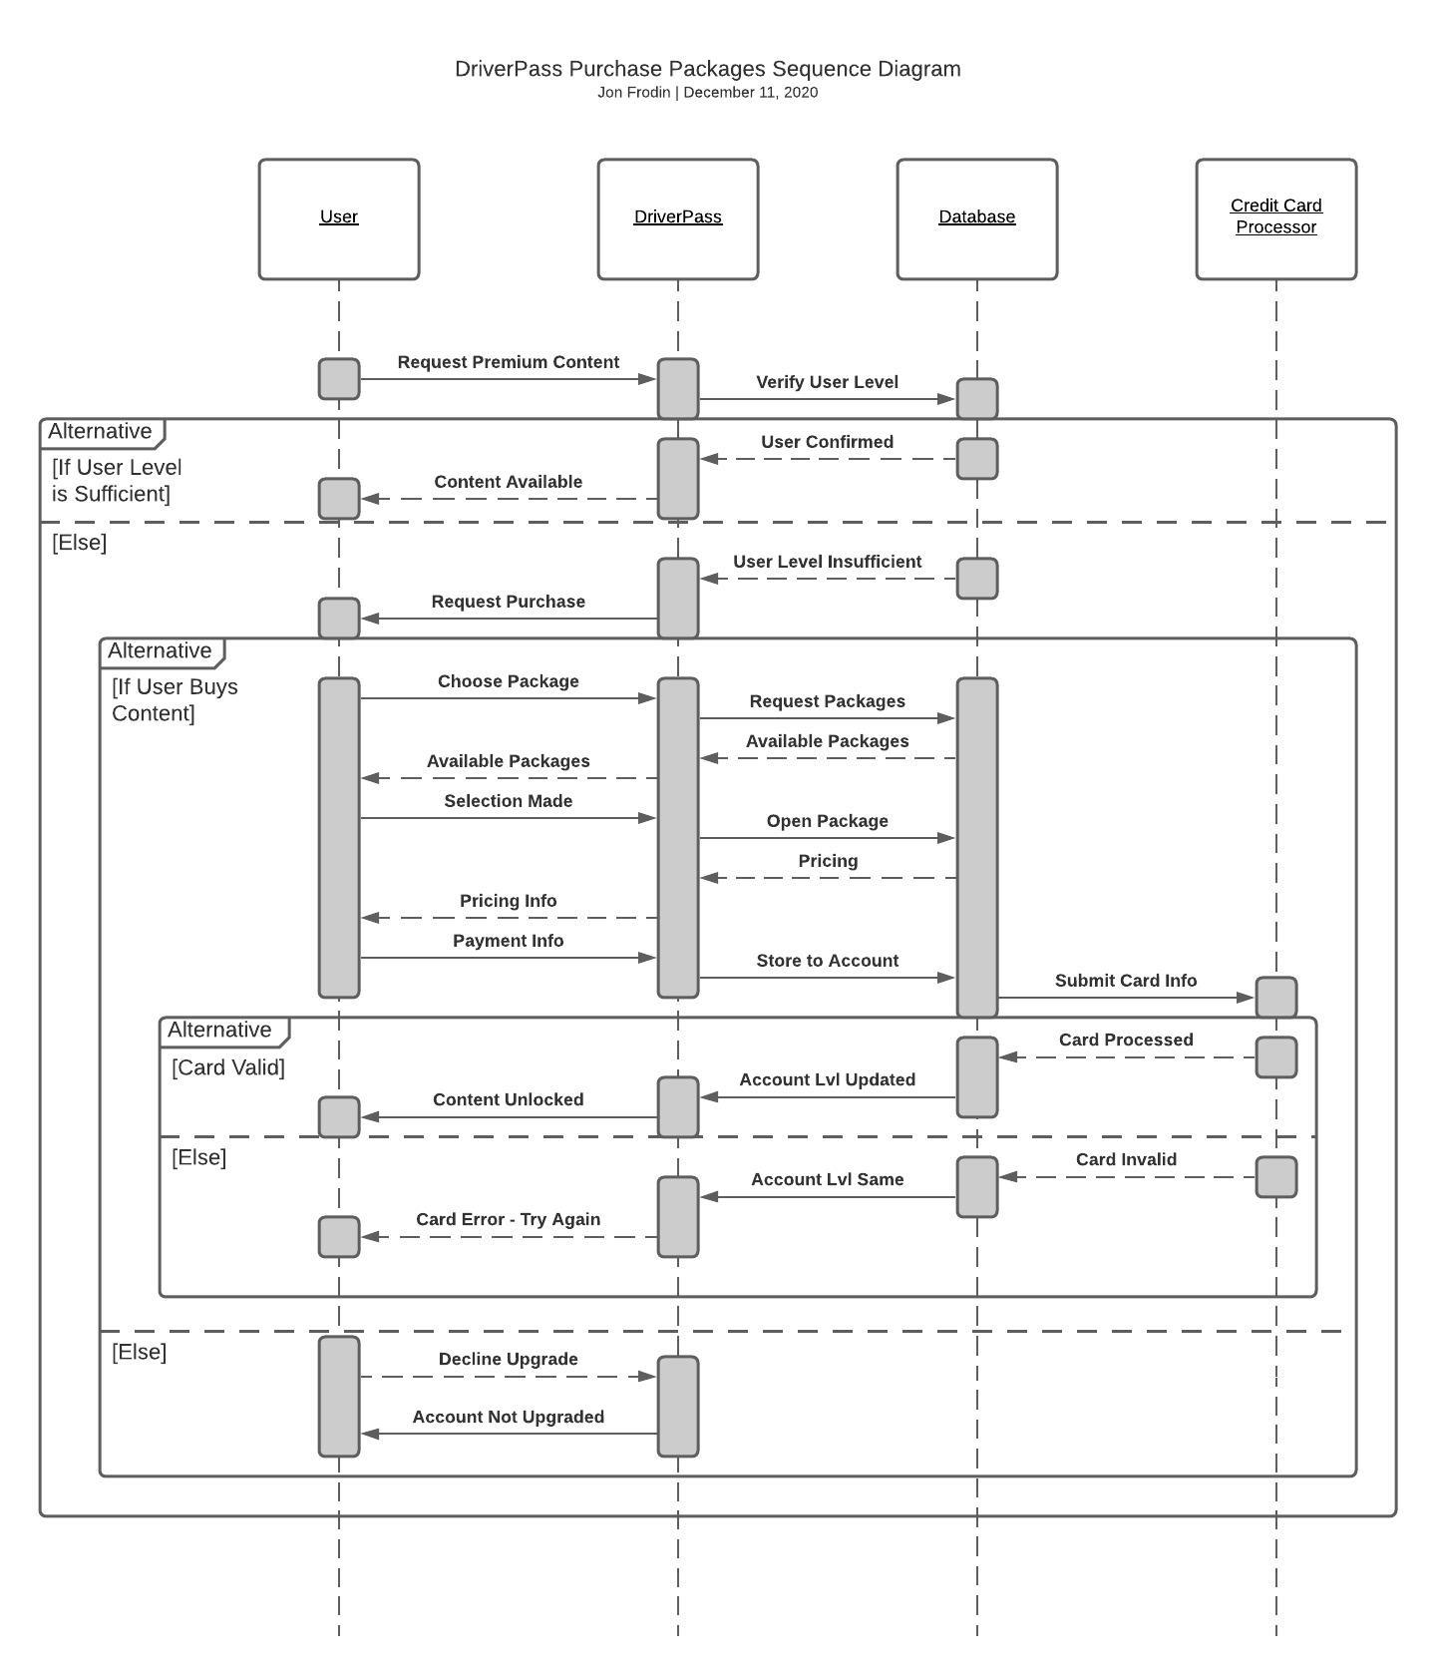

### UML Class Diagram

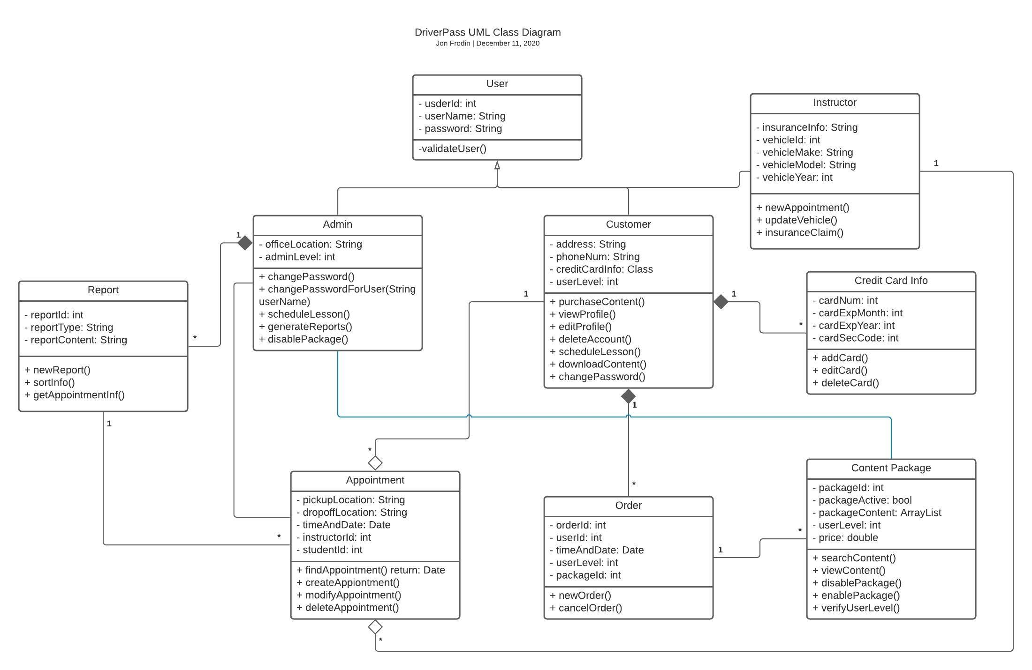

## Technical Requirements

Hardware Requirements for Host:

* At least one physical server
  + Prefer two for bilocation and backups
* Networking cables for the server and equipment
* Monitor, keyboard, and mouse for interaction
* Power sources
* Internet provider

Hardware Requirements for Client:

* Desktop or laptop computer
  + If desktop, then a mouse and keyboard and screen
* Wireless card or ethernet cable for networking
* Power sources
* Internet provider

Software Requirements for Host:

* Windows Server operating system
* DriverPass Software
* Docker software for controlling VM traffic
* Security software for protecting sensitive information from hacking

Software Requirements for Client:

* Web browser application (Firefox, Chrome, etc.)
* Operating system (Mac, Linux, Windows, etc.)
* Security software for protecting sensitive informataion

Tools Required for Development:

* Computers with programming software (Visual Studio, Eclipse, emacs, etc.)
* Internet connection for server upload
* Network admin tools for monitoring for suspicious traffic

Infrastructure Required:

* Server location or cloud provider
* Adequate power supplies to the building
* Adequate internet service to the building
  + Particularly adequate upload speeds
* Parking available for workers
* Cars for students/instructors
* Insurance as required by law in state of operations
* Credit card processing company contract